Blockchain and it’s Applications
Question Bank Unit 2
- Discuss DApps.
Ans.1) DApps (Decentralized Applications) is a key component of the blockchain ecosystem, playing a crucial role in shaping the landscape of decentralized and trustless systems.

Decentralized Applications (DApps):
1. Definition: DApps are applications that run on decentralized networks, leveraging blockchain or other DLTs. They operate without a central authority, relying on smart contracts and consensus mechanisms for execution.
2. Key Characteristics:
- Open Source: DApps are often built on open-source code, fostering community collaboration.
- Decentralized Storage: Data is stored on the blockchain or decentralized file systems.
- Smart Contracts: Self-executing contracts with predefined rules.
3. Types of DApps:
- Financial DApps: Decentralized finance (DeFi) applications for lending, borrowing, and trading.
- Gaming DApps: In-game assets and transactions recorded on the blockchain.
- Social DApps: Platforms where users have control over their data and interactions.
4. Advantages:
- Censorship Resistance: DApps are less prone to censorship due to their decentralized nature.
- Trustlessness: Users can interact without relying on a central authority.
- Security: Data integrity and security are enhanced by blockchain's cryptographic principles.
5. Challenges:
- Scalability: Some blockchain networks face challenges in handling a large number of transactions.
- User Experience: DApps may have a steeper learning curve for users unfamiliar with blockchain technology.
- Regulatory Uncertainty: Legal frameworks for DApps are still evolving.

DApps represent the practical applications that leverage this infrastructure, creating a new paradigm for trust, transparency, and peer-to-peer interactions. As the technology continues to evolve, the potential for innovative use cases across various industries remains significant.

- What are smart Contracts. Explain various types of smart contracts
Ans. 2) Smart contracts are self-executing contracts with the terms of the agreement directly written into lines of code. These contracts automatically enforce and execute the terms of an agreement when predefined conditions are met. They run on blockchain technology, ensuring transparency, security, and immutability.

There are various types of smart contracts based on their functionality and the blockchain network they operate on:

1. Simple Smart Contracts These are basic contracts with straightforward conditions and actions. They execute predefined actions when specific conditions are met.

2. Complex Smart Contracts These contracts involve multiple conditions and actions, allowing for more intricate agreements to be automated. They can handle a series of conditional statements and execute various actions based on different scenarios.

3. Multi-signature Smart Contracts Also known as multi-sig contracts, these require multiple parties to sign off on a transaction before it can be executed. They are commonly used for escrow services and joint accounts.

4. Oracle Smart Contracts These contracts interact with external data sources, known as oracles, to trigger actions based on real-world events. Oracles provide the smart contract with information from outside the blockchain.

5. Token Smart Contracts These contracts govern the creation, distribution, and management of tokens on a blockchain. They are commonly used for Initial Coin Offerings (ICOs), tokenization of assets, and creating decentralized applications (dApps).

6. Permissioned Smart Contracts These contracts operate on permissioned blockchains where access is restricted to authorized participants. They are suitable for enterprise applications that require privacy and control over network participants.

By leveraging smart contracts, parties can automate and streamline various processes, reduce the need for intermediaries, and ensure trustless execution of agreements. Smart contracts have the potential to revolutionize industries by enabling secure, transparent, and efficient transactions on blockchain networks.
- What is Blockchain. Draw and Explain structure of Block and block header.
Ans.3) A blockchain is a decentralized and distributed ledger technology that securely records and verifies transactions across a network of computers. It consists of a chain of blocks, each containing a list of transactions, linked together through cryptographic hashes. Blockchain is designed to be transparent, secure, and tamper-resistant, providing a reliable and decentralized way to record and verify digital transactions without the need for a central authority.

Structure of a Block: Each block in a blockchain contains specific information and follows a consistent structure. While there may be some variations depending on the blockchain platform, the fundamental components of a block typically include:
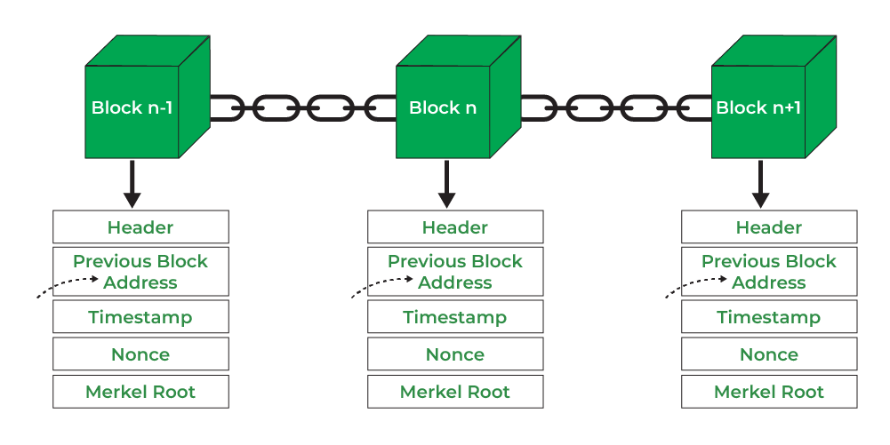

- Header: It is used to identify the particular block in the entire blockchain. It handles all blocks in the blockchain. A block header is hashed periodically by miners by changing the nonce value as part of normal mining activity, also Three sets of block metadata are contained in the block header.

- Previous Block Address/ Hash: It is used to connect the i+1th block to the ith block using the hash. In short, it is a reference to the hash of the previous (parent) block in the chain.

- Timestamp: It is a system verify the data into the block and assigns a time or date of creation for digital documents. The timestamp is a string of characters that uniquely identifies the document or event and indicates when it was created.

- Nonce: A nonce number which uses only once. It is a central part of the proof of work in the block. It is compared to the live target if it is smaller or equal to the current target. People who mine, test, and eliminate many Nonce per second until they find that Valuable Nonce is valid.

- Merkel Root: It is a type of data structure frame of different blocks of data. A Merkle Tree stores all the transactions in a block by producing a digital fingerprint of the entire transaction. It allows the users to verify whether a transaction can be included in a block or not.

The structure and consensus mechanisms may vary in different blockchain implementations, but the core principles of transparency, security, and decentralization remain consistent across blockchain technology.

The block header is a crucial component of a blockchain's structure, located at the beginning of each block. It contains essential information about the block and serves as the means to link one block to the previous block, forming the chain. The block header is hashed to create a unique identifier for the block, and it includes several key fields:
- Version Number:
Indicates the version of the blockchain protocol being used. This helps in maintaining compatibility and understanding the rules by which the block is validated.

- Previous Block Hash:
A reference to the hash of the previous block in the blockchain. This establishes the chronological order and continuity of the blockchain, as each block is linked to its predecessor.

- Merkle Root:
The Merkle root is the cryptographic hash of all the transactions included in the block. It is generated by organizing the transaction hashes in a Merkle tree structure, where each leaf node is a transaction hash, and the internal nodes are the hashes of their respective children. The Merkle root is a concise representation of all transactions in the block.

- Timestamp:
Indicates the time when the block is created. It helps in maintaining a chronological order and is a crucial factor in the consensus mechanism, especially for adjusting the difficulty of mining.

- Difficulty Target:
Represents the level of difficulty set for miners to find a valid hash. It is an important parameter that adjusts periodically to control the rate of block creation, ensuring a consistent block time.

- Nonce:
A random number used in the mining process. Miners repeatedly modify the nonce until a hash is found that meets the current difficulty target. The inclusion of the nonce ensures that the block's hash satisfies the network's consensus rules.

The block header is hashed using a cryptographic hash function, typically SHA-256 (Secure Hash Algorithm 256-bit), producing a fixed-length string of characters known as the block hash. This hash uniquely identifies the block and is a critical factor in the security and integrity of the blockchain. Even a small change in any part of the block header would result in a completely different hash, making it tamper-evident.

The linking of blocks through the block header's reference to the previous block's hash ensures the immutability and security of the entire blockchain. If an attacker were to alter the data in any block, it would change the block's hash, invalidating not only that block but also all subsequent blocks in the chain. This makes the blockchain resistant to tampering and provides a transparent and trustless record of transactions.

- What are Bitcoin scripts? Explain with example 7M
Ans. 4) Bitcoin scripts are a simple programming language used in Bitcoin transactions to define the conditions under which the funds can be spent. These scripts are embedded in the output of a transaction and are known as scriptPubKey (script public key). When a person wants to spend the funds received in a transaction, they must provide a script that satisfies the conditions set by the scriptPubKey.

The most common type of Bitcoin script is Pay-to-Public-Key-Hash (P2PKH). Here's an example of a P2PKH script:
Code :-
OP_DUP OP_HASH160 <Public Key Hash> OP_EQUALVERIFY OP_CHECKSIG
Explanation of the script:
- OP_DUP: Duplicates the top stack item.
- OP_HASH160: Applies the SHA-256 hash function followed by RIPEMD-160 to the duplicated item.
- <Public Key Hash>: This is the hash of the recipient's public key. It is typically the address to which the bitcoins are sent.
- OP_EQUALVERIFY: Compares the resulting hash with the hash provided in the script. If they are not equal, the transaction fails.
- OP_CHECKSIG: Checks the digital signature against the public key.
This script ensures that the spender possesses the private key corresponding to the public key hash provided in the script. Bitcoin's scripting language allows for various conditions and customization, enabling the creation of more complex smart contracts and multi-signature transactions.

- What are the steps for joining a bitcoin network? Explain.
Ans. 5) Joining the Bitcoin network involves setting up a Bitcoin wallet and connecting to the peer-to-peer network to become a participant in the decentralized system. Here are the general steps for joining the Bitcoin network:
- Choose a Bitcoin Wallet:
  - Select a Bitcoin wallet that suits your needs. Wallets come in various forms, including software wallets (desktop, mobile, or web), hardware wallets, and paper wallets. Ensure that the wallet you choose supports the features you require, such as security, ease of use, and compatibility with your device.
- Download and Install the Wallet:
  - If you opt for a software wallet, download the wallet software from the official website or a reputable source. Follow the installation instructions for your specific operating system.
- Set Up Your Wallet:
  - After installation, launch the wallet and follow the setup process. This typically involves creating a new wallet, securing it with a strong password, and generating a backup phrase (seed) that you should securely store offline.
- Receive a Bitcoin Address:
  - Your wallet will generate a Bitcoin address for you. This address serves as your public key, allowing others to send bitcoins to your wallet. You can share this address to receive funds.
- Obtain Bitcoin:
  - You can acquire Bitcoin by purchasing it on a cryptocurrency exchange, receiving it as a payment, or mining it (though mining is more complex and resource-intensive). You'll need some bitcoins in your wallet to participate in transactions.
- Connect to the Bitcoin Network:
  - Your wallet needs to connect to the Bitcoin network to send and receive transactions. This is typically done automatically by the wallet software. The wallet will synchronize with the blockchain, downloading the entire transaction history up to the current block.
- Wait for Synchronization:
  - The initial synchronization process may take some time, as your wallet downloads the entire history of the Bitcoin blockchain. This duration depends on your internet speed and the efficiency of the wallet software.
- Start Sending and Receiving Bitcoin:
  - Once your wallet is synchronized, you can start sending and receiving Bitcoin. Use your wallet interface to initiate transactions, and ensure you provide the correct recipient address when sending funds.
- Stay Informed:
  - Stay updated on Bitcoin news, security best practices, and any updates or improvements to your wallet software. Being informed helps you make well-informed decisions and stay secure in the rapidly evolving cryptocurrency space.

It's crucial to be mindful of security practices, such as keeping your private keys and backup phrases secure, using reputable wallet software, and staying vigilant against phishing attempts. Additionally, understand the risks and responsibilities associated with managing your own cryptocurrency assets.

- What is Double Spending? Explain how double spending is handled using blockchain 7M
Ans. 6) Double spending is a potential issue in digital currencies where the same unit of currency is spent more than once, leading to the creation of counterfeit or fraudulent transactions. In traditional centralized systems, the prevention of double spending relies on a trusted third party, such as a bank, to maintain a centralized ledger and verify the authenticity of transactions. However, in decentralized systems like blockchain, double spending is a significant challenge that requires a different solution.

How Blockchain Handles Double Spending:
- Consensus Mechanism:
  - Blockchain networks use consensus mechanisms to agree on the validity of transactions and prevent double spending. In the case of Bitcoin and many other cryptocurrencies, the most common consensus mechanism is Proof-of-Work (PoW). Miners compete to add new blocks to the blockchain by solving complex mathematical puzzles. The first miner to solve the puzzle gets the right to add a new block, including a set of transactions, to the blockchain. This decentralized and competitive process ensures that the network collectively agrees on the transaction history.
- Transaction Confirmation:
  - Once a transaction is included in a block and added to the blockchain, it receives a certain number of confirmations. Each additional block added to the blockchain after the block containing the transaction increases the level of confidence in the transaction's validity. For example, it is common to wait for multiple confirmations (typically six or more) before considering a transaction as fully confirmed and secure.
- Immutability and Tamper Resistance:
  - The blockchain's immutability and tamper-resistant nature play a crucial role in preventing double spending. Once a block is added to the blockchain, it is extremely difficult to alter or remove. Attempts to double spend by altering a transaction in a previous block would require a significant amount of computational power and control over the majority of the network, making it economically and technically infeasible.
- Network Agreement:
  - For a double spend to occur, an attacker would need to control more than 50% of the network's computational power, a scenario known as a 51% attack. Such an attack is not only difficult and expensive but also undermines the decentralized and trustless nature of the blockchain. The security of the blockchain relies on the assumption that the majority of participants in the network act honestly.
- Probabilistic Finality:
  - While the blockchain provides a high level of security against double spending, it's essential to understand that confirmations represent probabilistic finality. The deeper a transaction is in the blockchain (the more confirmations it has), the less likely it is to be reversed. However, in theory, it is always possible for a chain reorganization to occur, especially in the event of a network fork or attack. The probability of this happening decreases exponentially as more blocks are added to the chain.
In summary, blockchain's prevention of double spending relies on decentralized consensus mechanisms, transaction confirmations, immutability, and the security provided by the network's distributed nature. The combination of these factors ensures the integrity and trustworthiness of transactions recorded on the blockchain.

